Answers to H2 Chemistry Preliminary Examinations 2009 Paper 1 and 2

Paper 1

1 | B | 6 | D | 11 | D | 16 | A | 21 | B | 26 | A | 31 | B | 36 | C
2 | A | 7 | C | 12 | B | 17 | C | 22 | C | 27 | B | 32 | B | 37 | D
3 | A | 8 | D | 13 | C | 18 | C | 23 | C | 28 | D | 33 | B | 38 | A
4 | A | 9 | D | 14 | A | 19 | C | 24 | B | 29 | C | 34 | A | 39 | C
5 | B | 10 | C | 15 | D | 20 | C | 25 | C | 30 | A | 35 | A | 40 | C

Paper 2

1 | This question is about chlorine and its compounds.
 | (a) | A teacher instructed a student to react some chlorine gas with 250 cm³ of 0.100 mol dm⁻³ aqueous sodium hydroxide, and left the lab. After he returned, he realized that he had not specified the reaction temperature. The teacher found that the pH of the solution had become 12.0. After acidifying the solution and adding excess silver nitrate, 2.69 g of silver chloride was obtained. He then concluded that the student had heated the sodium hydroxide.  For this question, you may assume that all of the chloride ions are precipitated by the addition of silver ions.
 |  | (i) | Determine how the teacher arrived at his conclusion.  ● Number of moles of NaOH used = 0.250 x 0.100 – 0.250 x 10^{−(14 – 12.0)}  = 0.0225 mol  ● Number of moles of chloride = 2.69 / (107.8 + 35.5)  = 0.0188 mol  Number of moles of chloride : number of moles of NaOH  = 0.0188 : 0.0225  ● = 5 : 6  Which is in line with the equation:  3Cl₂ + 6OH⁻ → 5Cl⁻ + ClO₃⁻ + 3H₂O  [
 |  | (ii) | If the student had not heated the aqueous sodium hydroxide and the same amount of chlorine gas was used, what would be the resulting mass of silver chloride obtained when excess silver nitrate is added after acidifying the solution?  [5]  Number of moles of chlorine gas used = 0.0188 x 3 / 5  = 0.0113 mol  Cl₂ + 2OH⁻ → Cl⁻ + ClO⁻ + H₂O  ● Number of moles of chloride formed (cold) = 0.0113 mol  ● Mass of silver chloride formed = 0.0113 x (107.8 + 35.5)  = 1.62 g
 | (b) | The melting point of POCl₃ is 1.25 ºC whereas the melting point of PCl₅ is 166.8 ºC.
 |  | (i) | Name and draw diagrams to illustrate the shapes of POCl₃ and PCl₅.  • •  P  Cl  O  Cl  Cl  POCl₃  Tetrahedral  PCl₅  Trigonal bipyramidal  P  Cl  Cl  Cl  Cl  Cl
 |  | (ii) | Explain, in terms of structure and bonding, why PCl₅ has a higher melting point.  [4]
● POCl₃ and PCl₅ both are simple discrete molecules with weak van der Waals’ forces of attraction between the molecules (or POCl₃ has permanent-dipole-permanent-dipole interactions while PCl₅ has induced-dipole-induced-dipole interactions between molecules).
● PCl₅ has a much larger M_{r} than POCl₃, and therefore a larger electron cloud that is more easily distorted, giving rise to larger partial charges, resulting in stronger van der Waals’ forces.

 | (c) | Phosphorous pentachloride is commonly used in organic reactions such as the following:  CH₃OH(l) + PCl₅(s) CH₃Cl(g) + POCl₃(l) + HCl(g)
 |  | (i) | With reference to the Data Booklet and the following bond enthalpies, calculate the enthalpy change of the above reaction.  Bonds broken: C-O, 2 P-Cl, O-H  Bonds formed: C-Cl, P=O, HCl  • Enthalpy change of reaction = (460 + 360 + 2 x 331)  – (340 + 460 + 431)  = 1482 – 1231  ● = + 251 kJ mol^{–1} of CH₃OH
  Bond | Bond Energy / kJ mol⁻¹
  P=O | 460
  P-Cl | 331
 |  | (ii) | Deduce whether the entropy change is positive or negative and hence explain why the above reaction occurs at room temperature.  ● Entropy change is positive.  ● As the reactants are in liquid and solid states but the products contain two gases (CH₃Cl and HCl), this gives rise to a greater degree of disorder in the products.  ΔGº = ΔHº – TΔSº  ● Since ΔHº is positive and ΔSº is positive, room temperature must be sufficiently high that the magnitude of TΔSº exceeds the magnitude of ΔHº.
 |  | (iii) | Given that the actual standard enthalpy change of reaction is −104.3 kJ mol⁻¹, suggest two reasons for the discrepancy.  [7]  ● The values in the data booklet are average values, each taking into account the bond energies of the same bond in different compounds.  ● Bond energies are based on the compounds being in gaseous state but in the above reaction, CH₃OH, PCl₅ and POCl₃ are non-gaseous. (The discrepancy in value is due to the enthalpy change of fusion of PCl₅, and the enthalpy change of vapourisation of all three compounds).  [
 | (d) | A student mixed up three test tubes containing chlorobenzene, trichloromethane and ethanoyl chloride separately.
 |  | (i) | Describe a chemical test to first identify ethanoyl chloride from among the three test tubes.  ● Add acidified aqueous silver nitrate at room temperature to all three test tubes.  ● A white precipitate (of silver chloride) will be formed in the test tube with ethanoyl chloride, while no precipitate will be formed in the other two test tubes.
 |  | (ii) | Describe a second chemical test to then identify trichloromethane from among the remaining two test tubes.  [4]  ● Add aqueous sodium hydroxide to both test tubes and reflux. Then add excess dilute nitric acid followed by aqueous silver nitrate.  ● A white precipitate (of silver chloride) will be formed in the test tube with trichloromethane, while no precipitate will be formed in the other test tube.  [Total: 20 marks]

2 | The use of the Data Booklet is required for this question.
 | (a)  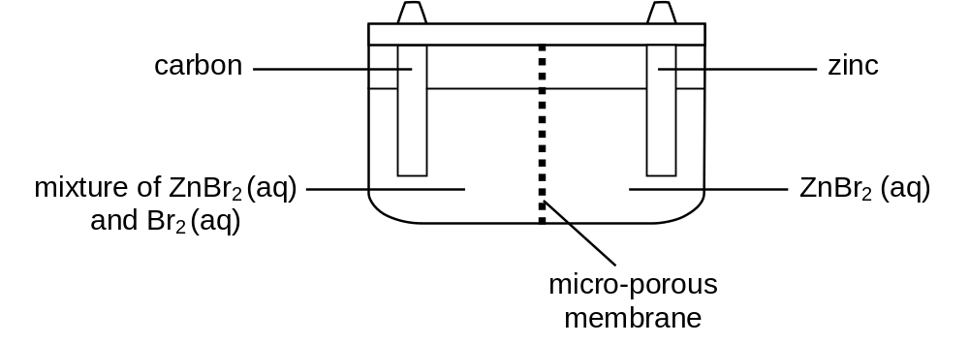 | Bromine is the only liquid non-metallic element at room temperature. It reacts vigorously with metals, especially in the presence of water, as well as most organic compounds, especially upon illumination.  Bromine is also used in the zinc-bromine flow battery which is a rechargeable battery. The two electrode chambers are separated by a micro-porous membrane which prevents bromine from reaching the zinc electrode where it would react with zinc, causing the battery to self-discharge. During the charging of the battery, bromide is converted to bromine.
 |  | (i) | In the table below, indicate the polarity (+/−) of the electrodes and write the half-equations for the electrode processes that occur when the battery discharges.
  Electrode | Polarity | Half-equation
  Zinc | −  • | • Zn(s) → Zn²⁺(aq) + 2e
  Carbon | + | • Br₂(aq) + 2e → 2Br⁻(aq)
 |  | (ii)  • | 4.2 g of bromine is formed in the cell when a current of 2.0 A is passed through it during charging. Determine the length of time required to form 4.2 g of bromine.  • Number of moles of electrons passed = 2 × (4.2 / 159.8)  = 0.0526 mol  Quantity of charge required = 0.0526 × 96500  = 5076 C  = I × t  ∴ time required = 5076 ÷ 2.0  = 2538 s
 |  | (iii) | In a research laboratory, a research worker first charged a zinc-bromine battery fully before adding 10 cm³ of 0.2 mol dm⁻³ sodium bromide solution to each of the two electrode chambers.  What is the effect on the electrical output of the battery when it is discharged?  [8]  • There is no effect to the position of equilibrium in the chamber containing Zn electrode and Zn²⁺(aq). Hence E_{Zn2+/ Zn} remains as −0.76 V.  • Br₂ (aq) + 2e 2Br⁻ (aq) E_{red} = +1.07 V  When the concentration of Br⁻(aq) increases in the chamber containing Br₂(aq) and Br⁻(aq), by Le Chatelier’s Principle, the system will try to remove the excess Br⁻ by pushing the position of equilibrium to the left, hence making the E_{red} less positive than +1.07 V.  • E_{cell} = E_{Br2/Br−} – E_{Zn2+/ Zn}  Hence the emf of the cell is reduced which reduces the amount of electrical energy produced.
 | (b) | Ethanol fuel cells are more practical than hydrogen fuel cells since ethanol is easier to store and transport than hydrogen. Ethanol is oxidised into carbon dioxide and water when the fuel cell is operated.  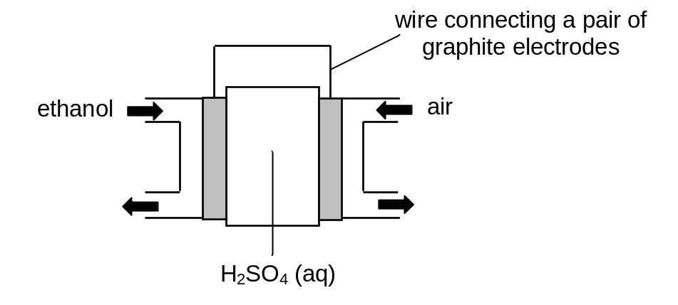
 |  | (i) | Write the half-equations taking place at each of the electrode:  Anode: • CH₃CH₂OH + 3H₂O → 2CO₂ + 12H⁺ + 12e  Cathode: • O₂ + 4H⁺ + 4e → 2H₂O  [2]
 |  | (ii) | Use appropriate data from the Data Booklet to explain why an acidic electrolyte is often preferred to an alkaline or neutral electrolyte.  [4]  • In an acidic medium, E^{θ}_{O2/H2O} = +1.23 V  while in an alkaline medium, E^{θ}_{O2/OH−} = +0.40 V  • Hence oxygen is a stronger oxidising agent in an acidic medium.
 | (c) | Ethanol can be oxidised to form ethanoic acid, which is used to prepare pyruvic acid, CH₃COCO₂H in a 3-step synthesis.  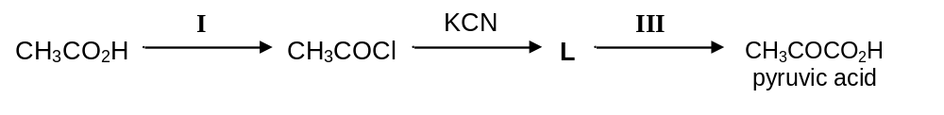
 |  | (i) | State the reagents and conditions for stages I and III.  Stage I: • PCl₅(s), room temperature  Stage III: • H₂SO₄(aq), heat
 |  | (ii) | Identify the intermediate compound, L.  [3]  • CH₃COCN  [Total: 15 marks]
3 | The first six ionisation energies of three successive elements in a Periodic Table are given below:
   | Ionisation energy in kJ mol⁻¹
  Element | 1st | 2nd | 3rd | 4th | 5th | 6th
  A | 786 | 1580 | 3230 | 4360 | 16100 | 19800
  B | 1060 | 1900 | 2920 | 4960 | 6270 | 21300
  C | 1000 | 2260 | 3390 | 4540 | 7000 | 8500
 | (a) | State and explain the group of the Periodic Table which element B belongs to.  [2]  • Element B belongs to Group V.  • There is a big jump in I.E. between the 5th and 6th electron removed which implies that the 6th electron removed lies in an inner quantum shell and is more strongly attracted by the nucleus. Hence more energy is required to remove the 6th electron.
 | (b) | Explain why the first ionisation energy of B is higher than the first ionisation energies of A and C.  [3]  Element A (Group IV) and B (Group V):  - The nuclear charge of B is higher than that of A, while their screening effect is approximately the same since both have the same number of occupied quantum shells.  - The increase in nuclear charge outweighs the increase in screening effect resulting in a higher effective nuclear charge for B. The valence electron to be removed from B is more strongly attracted by the nucleus, therefore it has a higher 1st I.E. than A.  Element B (Group V)and C (Group VI):  • The valence electron to be removed from C is one of the paired electrons in the p orbital. It experiences inter-electron repulsion, therefore less energy is required to remove it.  [Total: 5 marks]
4 | Tertiary structure refers to the complete three-dimensional structure of the polypeptide units of a given protein. Included in this description is the spatial relationship of different secondary structures to one another within a polypeptide chain and how these secondary structures themselves fold into the three-dimensional form of the protein. Secondary structures of proteins often constitute distinct domains. The secondary protein structure is the specific geometric shape caused by intramolecular and intermolecular bonding of amide groups.
 | (a) | Draw a diagram showing three strands of an anti-parallel β-pleated sheet structure of a protein. On the diagram, indicate the type of intermolecular force that holds the protein chains together.  [2]  • Anti-parallel, three strands, correct repeat unit, correct orientation of bonds to score 1 mark  • If above is met, then 1 mark awarded for hydrogen bonds between strands between C=O to N-H  Hydrogen bond  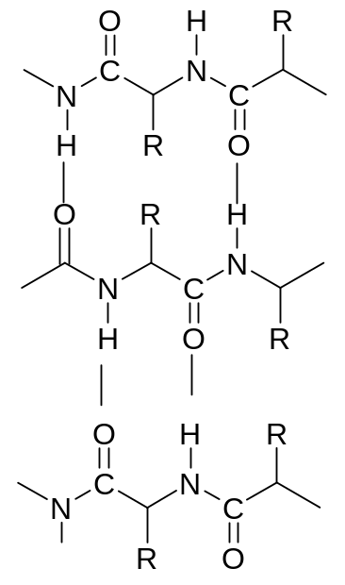
 | (b) | When a protein is denatured, the tertiary structure is disrupted. Explain in chemical terms how R group interactions are broken in each of the following situations. In your answer, identify the type of R group interaction which is broken for each example.  [R group = alkyl group]
 |  | (i) | In the presence of metal ions, e.g. Ag⁺.  ● Ionic bonds are broken  ● Negatively charged R groups form salts or complex ions with the metal ions, e.g. –COO⁻Ag⁺  OR  ● Disulphide linkages are broken  ● Ag⁺ will break the S—S bond (e.g. –CH₂ – S – Ag)  OR  ● hydrogen bonds / permanent-dipole-permanent dipole interactions are broken  ● Ag⁺ will interrupt electrostatic forces between polar R-groups
 |  | (ii) | At pH 2.  [4]  ● Ionic bonds are broken  ● Addition of H⁺ neutralizes/protonates basic/alkaline groups,  e.g. –COO⁻ + H⁺ → –COOH  OR  ● hydrogen bonds / permanent-dipole-permanent dipole interactions are broken  ● Addition of H⁺ neutralizes/protonates basic/alkaline groups,  e.g. –NH₂ + H⁺ → –NH₃⁺  [Total: 6 marks]
5 | (a) | Cocaine is commonly used in drug abuse but medicinally, it is valued as a local anaesthetic. Synthetic drugs developed from cocaine have been introduced to provide safer, less toxic local anaesthetic action. One of them is lignocaine which is currently the most widely used anaesthetic, having rapid action, effective absorption and good stability.  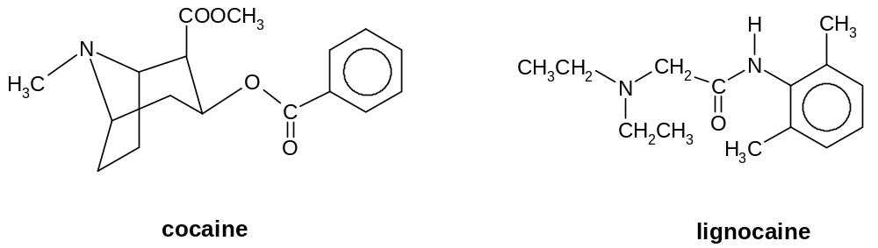
 |  | (i) | Identify the functional groups that are present in lignocaine.  - Tertiary amine  - Substituted amide
 |  | (ii) | Label all the chiral centres in the two molecules above with asterisk (*).  • 4 chiral centres in coaine  • 0 chiral centre in lignocaine  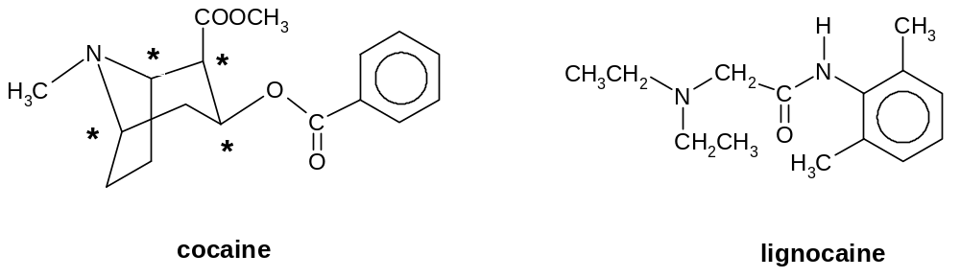
 |  | (iii) | When lignocaine is boiled with aqueous sodium hydroxide, two compounds, X and Y, are formed. X is soluble in aqueous sodium hydroxide while Y is immiscible with aqueous sodium hydroxide.  Identify the structural formula of X and Y.  X  •  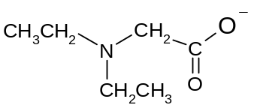  Y  •  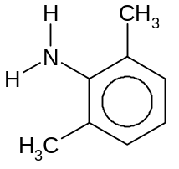
 |  | (iv) | Explain why X is soluble in aqueous sodium hydroxide while Y is immiscible with aqueous sodium hydroxide.  [8]  - X is an ionic salt and it can form ion-dipole attractions with water molecules. The energy released from the ion-dipole attractions is sufficient to overcome the ionic bonds in X as well as the hydrogen bonding between water molecules. As a result, X is soluble in water. (NB : hydrogen bonding between X and water is possible due to presence of electronegative N in X but is not extensive enough to explain solubility of X in water)  - Although Y has an amine group, it has a large hydrophobic benzene ring. The attraction between molecules of Y and water is mainly weak van der Waals forces and the energy released from these attractions is insufficient to overcome the strong hydrogen bonding between water molecules and the van der Waals forces between molecules of Y. Hence Y cannot intermingle with the water molecules and it is insoluble in water.

 | (b)  T + U | Using simple molecules like 2,6-dimethylphenylamine, ammonia and chloroethane, lignocaine can be synthesised as shown below.  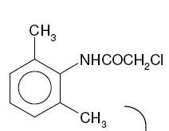  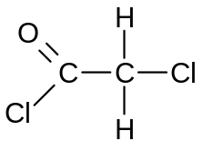  •  r.t.p.  S  T  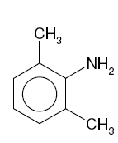  +  •  U  heat in  sealed tube  NH₃ + CH₃CH₂Cl  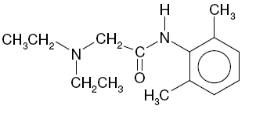  lignocaine
 |  | (i) | Draw the displayed structural formulae of the starting material, S and the intermediate, U in the boxes above.
 |  | (ii) | What problem do you foresee in the synthesis of intermediate U? Explain briefly.  • Intermediate U is a stronger nucleophile compared to NH₃ due to the positive inductive effect from the two alkyl groups attached to the nitrogen atom.  • U can react with excess CH₃CH₂Cl to form 3º amines or quaternary salt eg. (CH₃CH₂)₃N or (CH₃CH₂)₄N⁺Cl⁻. Hence a mixture of substituted products is obtained.
 |  | (iii) | T can be used as a starting material to synthesise 4-bromo-2,6-dimethyl phenylamine via the following route:  •  V  NaOH(aq)  reflux  T  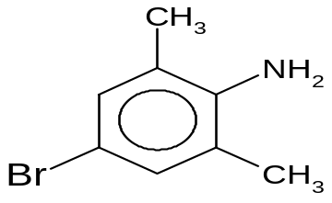
 |  |  | In the box above, draw the structure of V.
 |  | (iv) | State the reagent and condition to convert V to 4-bromo-2,6-dimethyl phenylamine.  [6]  • Br₂(aq), room temperature  [Total: 14 marks]

